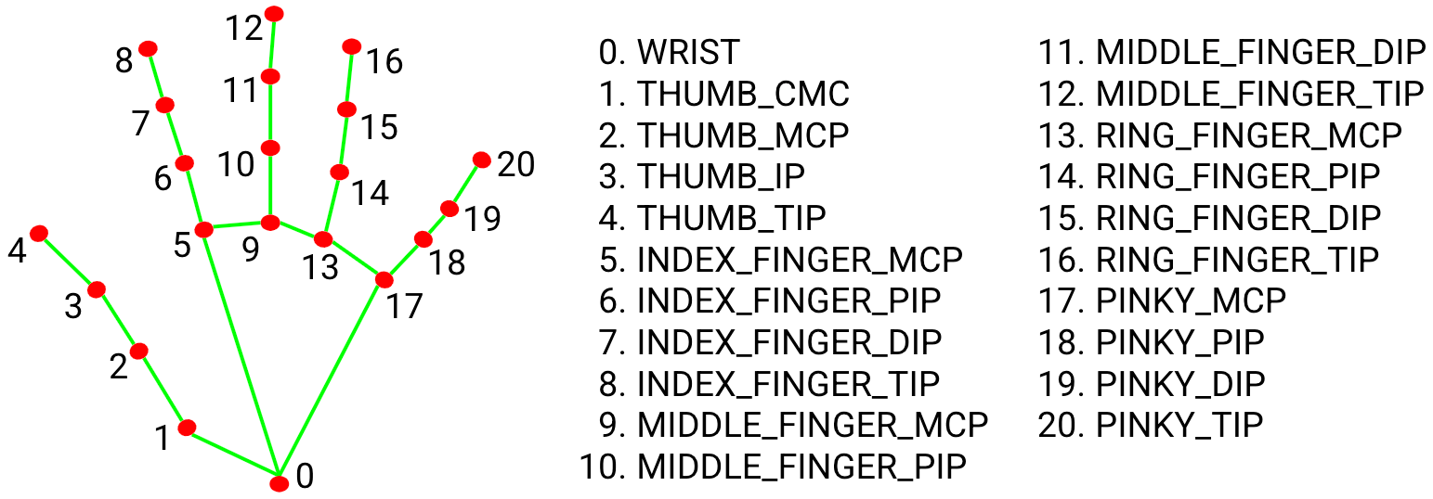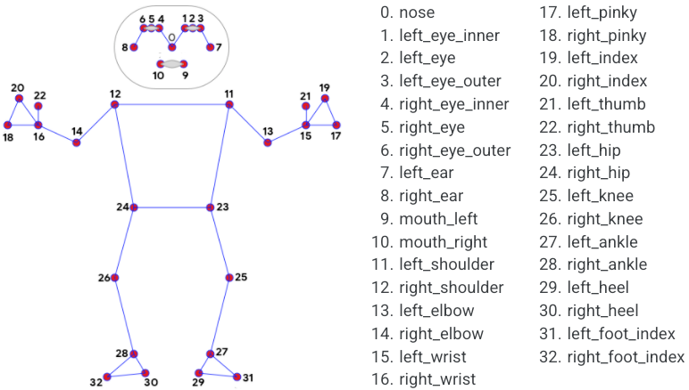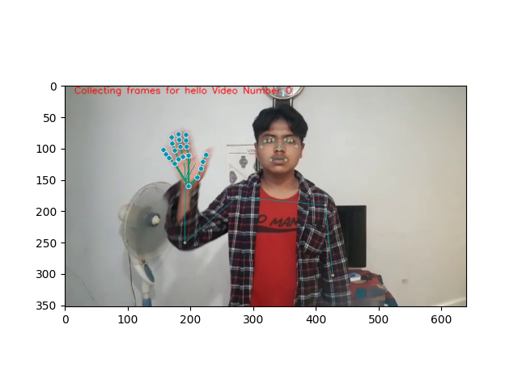

DATA EXTRACTION :

Pose Data :

Pose: ['ID:', 0, 'Landmark:', 'X:', 341, 'Y:', 101]

Pose: ['ID:', 1, 'Landmark:', 'X:', 351, 'Y:', 86]

Pose: ['ID:', 2, 'Landmark:', 'X:', 357, 'Y:', 87]

Pose: ['ID:', 3, 'Landmark:', 'X:', 361, 'Y:', 87]

Pose: ['ID:', 4, 'Landmark:', 'X:', 332, 'Y:', 86]

Pose: ['ID:', 5, 'Landmark:', 'X:', 326, 'Y:', 87]

Pose: ['ID:', 6, 'Landmark:', 'X:', 319, 'Y:', 88]

Pose: ['ID:', 7, 'Landmark:', 'X:', 369, 'Y:', 96]

Pose: ['ID:', 8, 'Landmark:', 'X:', 313, 'Y:', 97]

Pose: ['ID:', 9, 'Landmark:', 'X:', 352, 'Y:', 118]

Pose: ['ID:', 10, 'Landmark:', 'X:', 328, 'Y:', 118]

Pose: ['ID:', 11, 'Landmark:', 'X:', 415, 'Y:', 190]

Pose: ['ID:', 12, 'Landmark:', 'X:', 274, 'Y:', 177]

Pose: ['ID:', 13, 'Landmark:', 'X:', 427, 'Y:', 302]

Pose: ['ID:', 14, 'Landmark:', 'X:', 191, 'Y:', 250]

Pose: ['ID:', 15, 'Landmark:', 'X:', 453, 'Y:', 325]

Pose: ['ID:', 16, 'Landmark:', 'X:', 192, 'Y:', 153]

Pose: ['ID:', 17, 'Landmark:', 'X:', 469, 'Y:', 333]

Pose: ['ID:', 18, 'Landmark:', 'X:', 190, 'Y:', 120]

Pose: ['ID:', 19, 'Landmark:', 'X:', 470, 'Y:', 316]

Pose: ['ID:', 20, 'Landmark:', 'X:', 201, 'Y:', 113]

Pose: ['ID:', 21, 'Landmark:', 'X:', 461, 'Y:', 311]

Pose: ['ID:', 22, 'Landmark:', 'X:', 208, 'Y:', 124]

Pose: ['ID:', 23, 'Landmark:', 'X:', 387, 'Y:', 391]

Pose: ['ID:', 24, 'Landmark:', 'X:', 285, 'Y:', 390]

Pose: ['ID:', 25, 'Landmark:', 'X:', 385, 'Y:', 549]

Pose: ['ID:', 26, 'Landmark:', 'X:', 287, 'Y:', 551]

Pose: ['ID:', 27, 'Landmark:', 'X:', 383, 'Y:', 699]

Pose: ['ID:', 28, 'Landmark:', 'X:', 289, 'Y:', 698]

Pose: ['ID:', 29, 'Landmark:', 'X:', 385, 'Y:', 719]

Pose: ['ID:', 30, 'Landmark:', 'X:', 286, 'Y:', 717]

Pose: ['ID:', 31, 'Landmark:', 'X:', 368, 'Y:', 746]

Pose: ['ID:', 32, 'Landmark:', 'X:', 303, 'Y:', 746]

Multi-Hands Data :

Right Hand: ['ID:', 0, 'Landmark:', 'X:', 197, 'Y:', 160]

Right Hand: ['ID:', 1, 'Landmark:', 'X:', 211, 'Y:', 146]

Right Hand: ['ID:', 2, 'Landmark:', 'X:', 217, 'Y:', 132]

Right Hand: ['ID:', 3, 'Landmark:', 'X:', 220, 'Y:', 121]

Right Hand: ['ID:', 4, 'Landmark:', 'X:', 225, 'Y:', 110]

Right Hand: ['ID:', 5, 'Landmark:', 'X:', 197, 'Y:', 111]

Right Hand: ['ID:', 6, 'Landmark:', 'X:', 194, 'Y:', 97]

Right Hand: ['ID:', 7, 'Landmark:', 'X:', 193, 'Y:', 87]

Right Hand: ['ID:', 8, 'Landmark:', 'X:', 193, 'Y:', 78]

Right Hand: ['ID:', 9, 'Landmark:', 'X:', 188, 'Y:', 113]

Right Hand: ['ID:', 10, 'Landmark:', 'X:', 184, 'Y:', 97]

Right Hand: ['ID:', 11, 'Landmark:', 'X:', 182, 'Y:', 86]

Right Hand: ['ID:', 12, 'Landmark:', 'X:', 181, 'Y:', 77]

Right Hand: ['ID:', 13, 'Landmark:', 'X:', 181, 'Y:', 117]

Right Hand: ['ID:', 14, 'Landmark:', 'X:', 175, 'Y:', 103]

Right Hand: ['ID:', 15, 'Landmark:', 'X:', 171, 'Y:', 92]

Right Hand: ['ID:', 16, 'Landmark:', 'X:', 170, 'Y:', 82]

Right Hand: ['ID:', 17, 'Landmark:', 'X:', 175, 'Y:', 124]

Right Hand: ['ID:', 18, 'Landmark:', 'X:', 166, 'Y:', 115]

Right Hand: ['ID:', 19, 'Landmark:', 'X:', 161, 'Y:', 109]

Right Hand: ['ID:', 20, 'Landmark:', 'X:', 157, 'Y:', 102]

Model: "sequential"

_________________________________________________________________

Layer (type) Output Shape Param #

=================================================================

conv1d (Conv1D) (None, 60, 64) 16576

_________________________________________________________________

conv1d_1 (Conv1D) (None, 60, 128) 8320

_________________________________________________________________

flatten (Flatten) (None, 7680) 0

_________________________________________________________________

dense (Dense) (None, 32) 245792

_________________________________________________________________

dense_1 (Dense) (None, 32) 1056

_________________________________________________________________

dense_2 (Dense) (None, 7) 231

=================================================================

Total params: 271,975

Trainable params: 271,975

Non-trainable params: 0

_________________________________________________________________

None

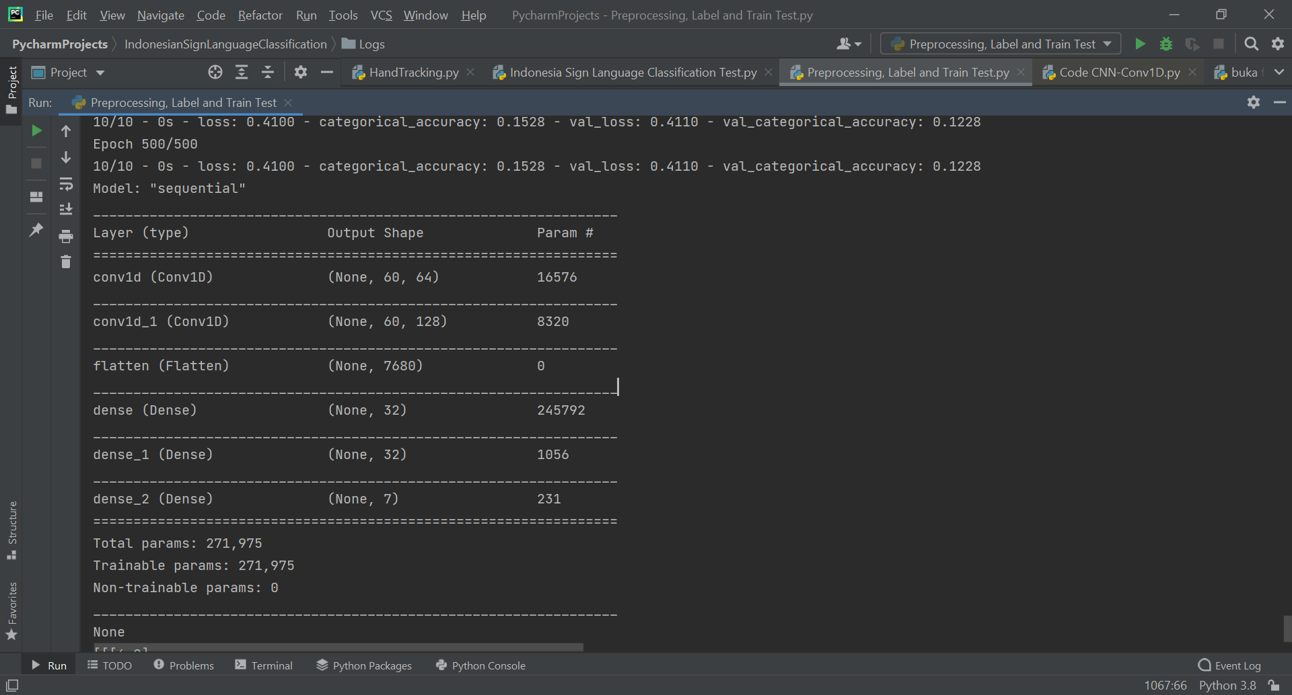

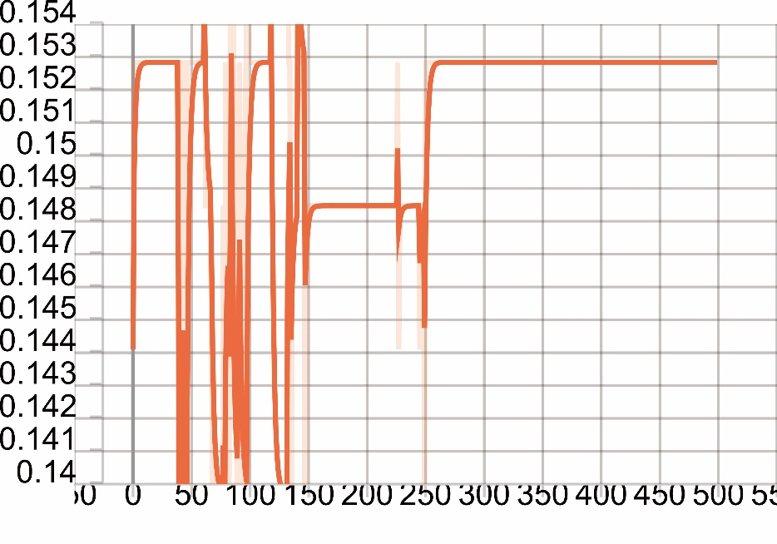Epoch Categorical Accuracy

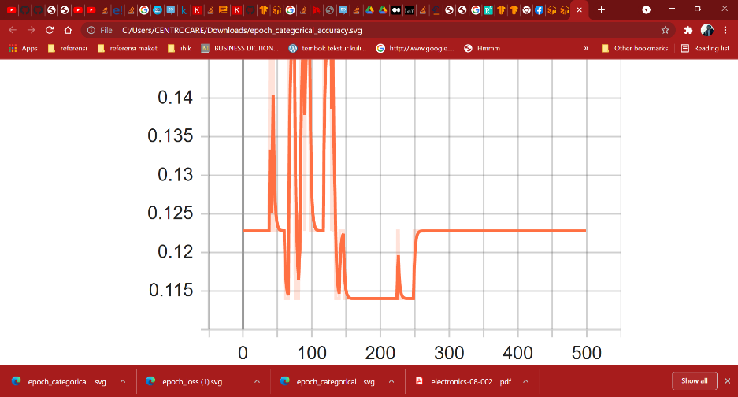Epoch Validation Categorical Accuracy

Loss

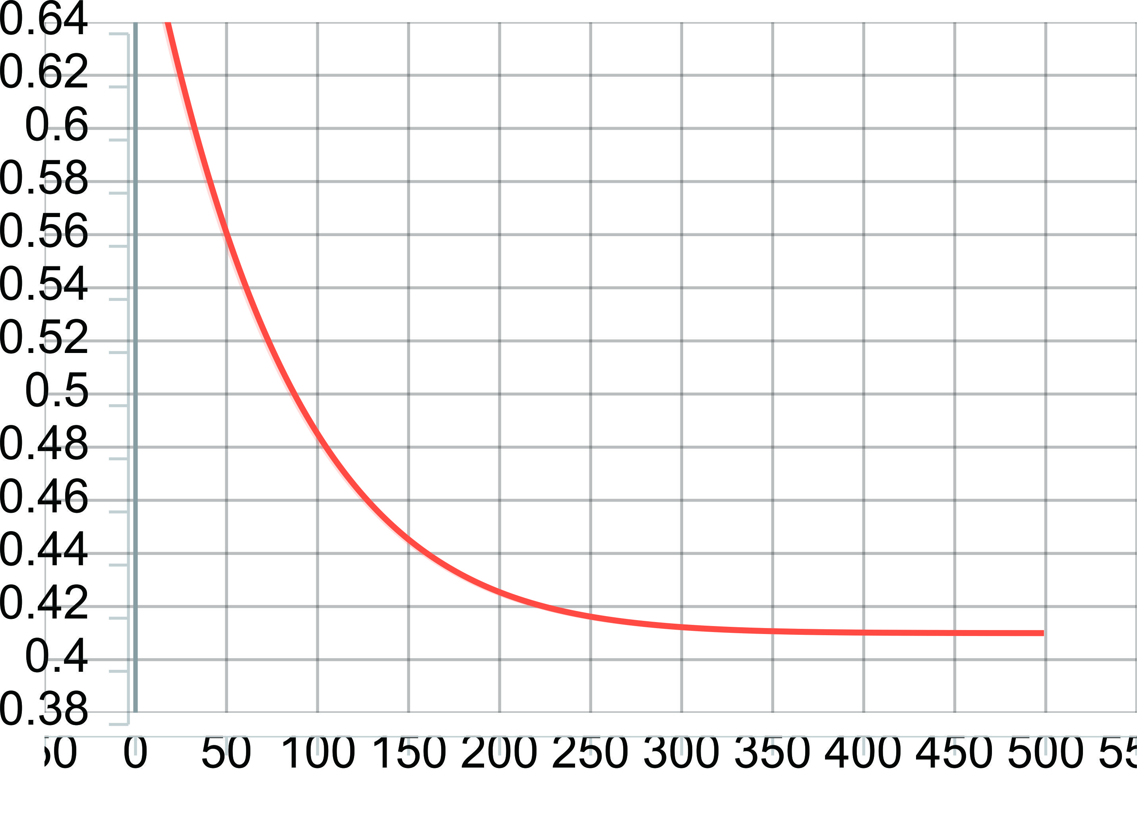

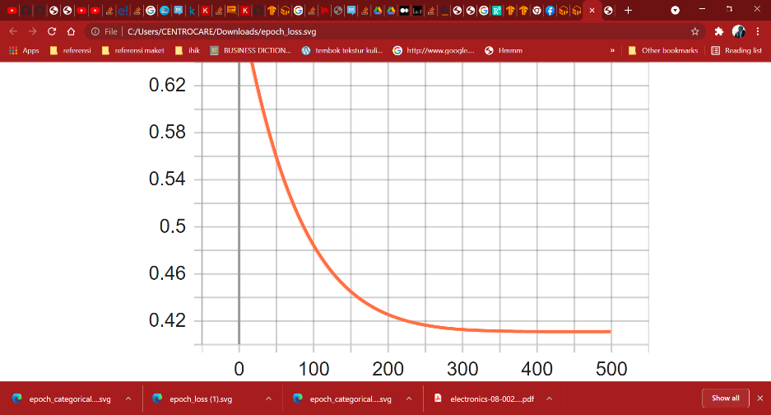Validation Loss

